**A New Opportunity at CPSL Mind:**

**Volunteer Facilities Assistant**

CPSL Mind is a vibrant, values-led charity that supports local people in their recovery from mental health challenges, promotes wellbeing and campaigns against stigma and discrimination.

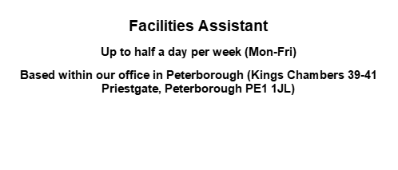

We are seeking a volunteer to support the IT and Facilities Coordinator to ensure the smooth running of the Peterborough office and to support the delivery of high-quality services.

 Supporting in general administration, health and safety and light maintenance.

We ask all volunteers to apply if they can commit to at least 6 months.

For full details of this role please have a look at the Role Specification.

***We are an equal opportunities employer and welcome applications from all sections of the community.***

**To apply, please visit our website:** [**www.cpslmind.org.uk**](http://www.cpslmind.org.uk/) **to complete a CPSL Mind Application Form, then attach your completed Equality & Diversity Monitoring**